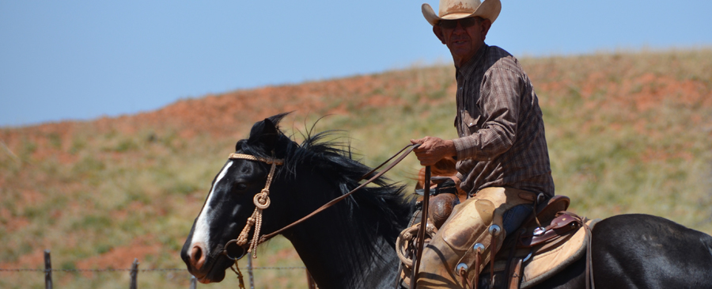
Texoma Cowboy
Church
Cowboying for
jesus

July 2016 Issue # 1

2 4 D by Pastor John

Happy Independence Day! There is no doubt that we have moved from spring to summer. The thermometer is pressing the 100-degree mark as I sit down to put some thoughts on paper. The Lord has blessed us with a very wet spring and the cattle are fat, wheat is nearly cut, cattle shipped and calves worked. Many ranchers and farmers are busy spraying this year’s crop of weeds not to mention baling hay! I’d like to some spiritual “application” to weeds in relation to our own lives.
Any successful rancher will tell you he is more than a good cowman; he is also a grass farmer. Now I'd rather take a beating as spend several weeks bouncing around on a tractor spraying pastures, but for years that's where you could find me the month of May. There is a phenomenon that happens every spring when conditions are just right, the weed seeds that have laid dormant all winter, explode onto the scene, and if not dealt with will greatly impact your grazing and production. 2 4 D better known as ragweed death row, is designed to kill only the weeds and not the grass. You can sure tell who did and who didn't spray. It's time and money well spent.
In my own life, there’s a phenomenon that happens when conditions are just right, something explodes from my mouth, a bad attitude rears its ugly head, and I'll think to myself, "where did that come from?" The truth is it was there all the time lying dormant waiting for the right conditions. The bible says that out of the abundance of the heart the mouth speaks.

I'm thankful god has an herbicide that can target those things in my life. It's why he sent his son Jesus to give his life for you and me.
God's herbicide is called 2 B 4 given!
1 John 1:9 If we confess our sins, he is faithful to forgive our sins and cleanse us from all unrighteousness.
I know our lives will never be weed free, but he promises that he makes me to lie down in green pastures.

News from the Ranch

Here at TCC, we have had a great spring as well. What a blessing it is for us to witness God’s hand at work in the lives of the people of our church. I am so thankful for the salvation and baptisms of many new believers, the spiritual hunger of many who are also involved in our round pen bible studies. We are blessed to see new faces every week as God continues to give us the opportunity to share the good news of His gospel every day.
Our Teams have been very busy as well hosting, serving, and ministering through many different avenues and events. I want to thank each of you personally for the work you do for our Lord in the building of His Kingdom. On a side note, I want to personally invite and challenge all who are ready this, if not already to get involved in serving your Lord and this body of Christ here at TCC. We had many needs within our ministry teams and want to encourage you to seek out where to serve.

We want to welcome a new ministry here at TCC. The “SICK” pen addiction ministry that is off and running and already having as many as 50 people coming to the Christ Centered 12 step program. God is working mightily in the lives of this team as they help meet one of the greatest needs in the Wichita Falls area! Please be in PRAYER for those ministering on this team along with all the rest of the wonderful ministries of our church.
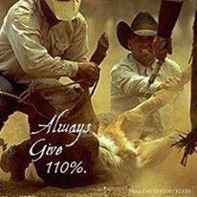
We are also having a lake baptism on July 24 at lake Arrowhead. We will have good ole picnic, games, fellowship followed by baptisms. Please contact Dianna at the office with any questions. This will be an awesome time of celebration and fellowship.
Cowboying For Jesus
Pastor John Riggs

